Pollinator Pods
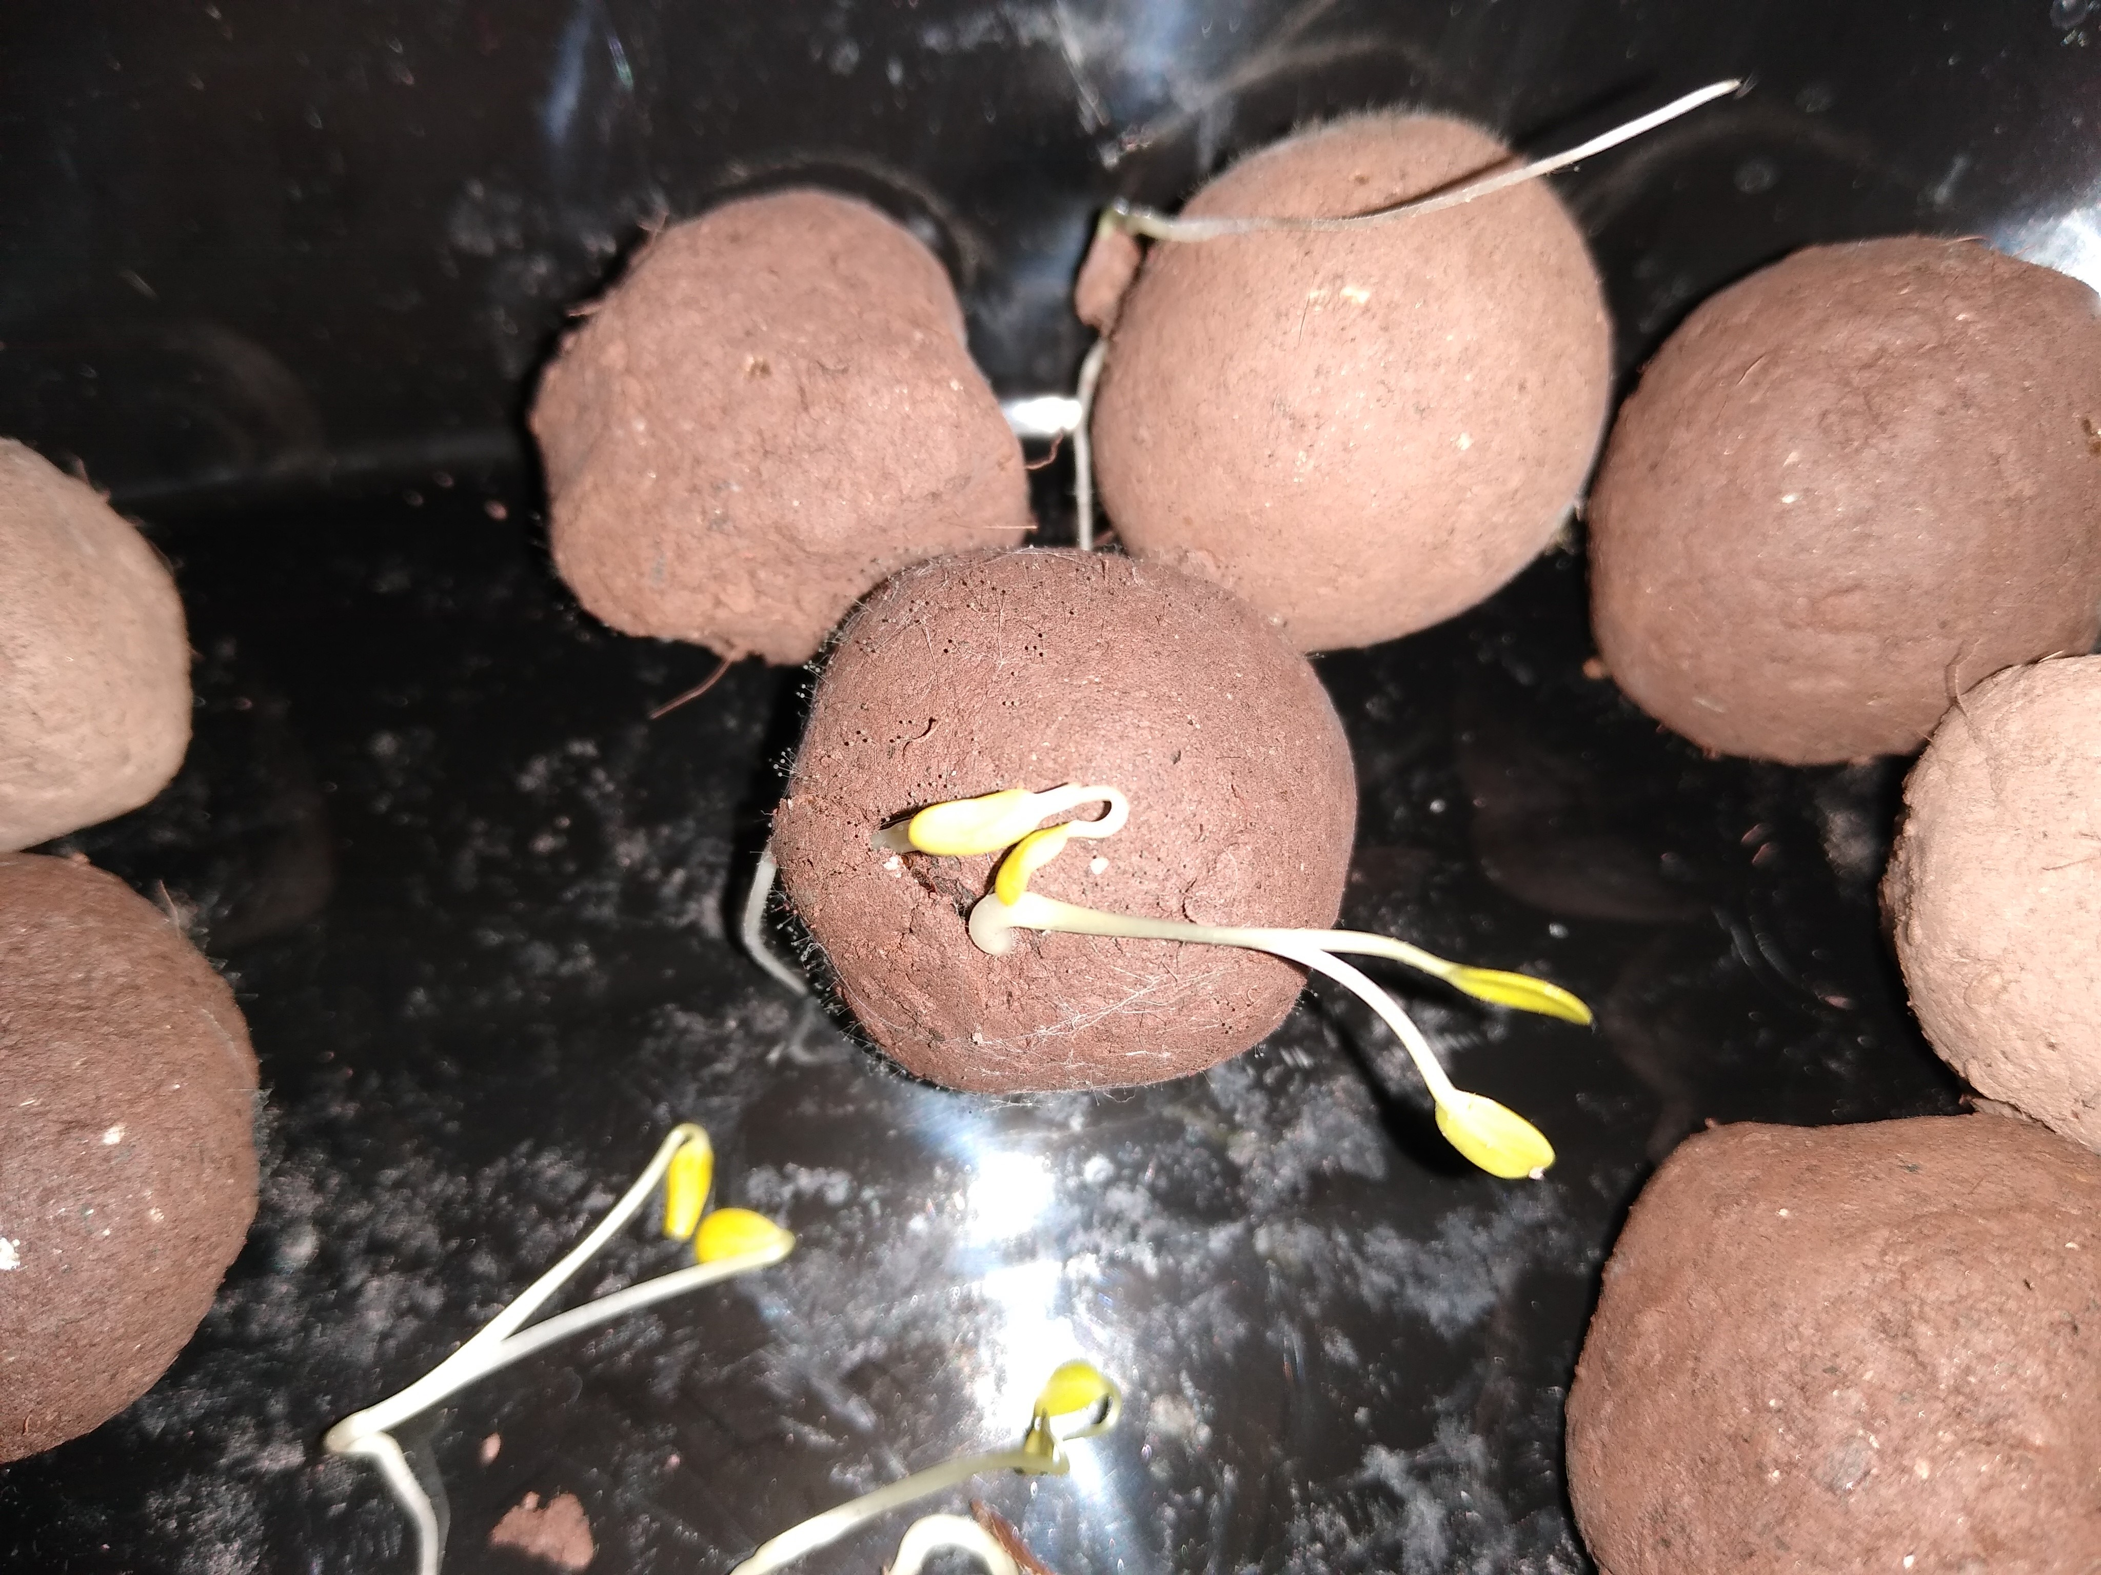
What are Pollinator Pods?
Pollinator Pods are native seeds and dirt formed into balls as an easy way to help people plant flowers. You wrap a couple seeds in a ball of soil materials (generally clay and compost) and dry it (or plant it right away). Then you deposit the seed ball somewhere. These pre-planted seed balls keep the seed safe until the time is right for germination.
- Additional benefits
  - Traditional methods of broadcasting seeds drawbacks include sowing seed on top of soil where it could be baked by the sun, blown away by wind, washed away, or nibbled by animals
  - In dry areas, the ball breaks apart and gives the seedling a tiny bit of shade
How to make
- Make the soil matrix of mixing clay and dirt.
- Take a pinch of enough soil matrix to create a tiny, dime-sized ball. Put 3 seeds inside. Large seeds can be deep inside the seed balls, while small seeds should be near the surface – they won’t be able to break out from deep inside the seed ball to germinate
- Roll the ball
- Dry them for 24-48 hours in the sun
- Store in a cardboard box or sow
How to plant
- Throw them on the ground!
- You can also press them gently into the soil about ½ way down
When to plant
- Short answer: Plant these seed balls in autumn
- Long answer:
  - If planting outside
    - some milkweed species need to be vernalized (cold-treated) before planting in the spring
    - Some seeds are not vernalized, so it’s easiest to plant in the fall, when the winter season will serve to naturally cold-treat them so they can germinate in the spring
  - Fall planting tends to be easier because winter should naturally cold-stratify the seeds, and if some don’t germinate you have a second chance in spring to plant them
  - If planting in spring, cold-treat the seeds, then heat-shock them, then plant. Can plant outside, or for best germination start them indoors

What seeds are best
- Pink Swamp Milkweed (Asclepias incarnata) –host plant for monarch butterflies
- Butterfly Milkweed Asclepias tuberosa)
- Common Milkweed Asclepias syriaca
- American Partridge Pea Chamaecrista fasciculata

Don’t have a place for seed balls? Make some for the garden here!
Suggestions for making them:
- Common Milkweed Seedball
- Butterflyweed Seedball
- Partridge pea Seedball
- Mix all seeds together for a variety seedball

What seedball matrix is made of
- Humus
  - Humus is dark, organic material that forms in soil when plant and animal matter decays.
- Vermicompost
  - is worm poop! The worms are grown specially for producing high quality soil and help break down food waste.
  - Did you know that worms have little gizzards, like chickens? If rearing worms for vermicompost, you have to make sure to occasionally feed them gritty things like coffee grounds or eggshells so their gizzards can work
- Bokashi tea
  - The partially fermented liquid generated from kitchen scraps being composted.

Seedball table supplies:
- Talking points on seed balls, and butterfly conservation
- Instructions on how to make seedballs to place on table
- Sign up sheet to get emailed an informational collection of papers on how to create seedballs
- Instructions on how to plant seed balls
- Materials
  - Seed ball matrix
  - Seeds
  - Plastic bags to take away seed balls
  - Pictures of monarchs and other pollinators, and the final flowers
  - wipes for cleaning hands
  - Gloves
  - Clicker
  - Garbage containers for the gloves and wipes
  - Tape to hold down the covering
  - Sample seed balls
  - Plates
  - Things to hold up plastic signs
  - Pencils

